# [Goal Pulse] Site Plan

## [Chance Tuft]

## WDD 130

## Overview

### Purpose

[The purpose of this website is to provide useful and inspiring content about soccer for fans and players for all skill levels. The site’s goal is to build a community that loves soccer through tips, highlights, and guides.]

### Audience

[The primary audience will be soccer players, young athletes, new fans, and anyone that is interested in learning more about the sport. The site will also attract casual viewers who want to keep up with the news, skills, and culture.]

## Branding

### Website Logo



## Style Guide

### Color Palette

|  |  |  |  |
| --- | --- | --- | --- |
| **Primary** | **Secondary** | **Accent 1** | **Accent 2** |
| #0A2647 | 6BD425 | #2C74B3 | #F1F6F9 |

### Typography

#### Heading Font: [Oswald]

#### Paragraph Font: [Roboto]

### Navigation

Home Game Changer Tips Behind the Goals

**Content**

Home Page

1. Heading #1 text:

Kickstart Your Passion for Soccer

2. Picture #1:



3. Paragraph text #1:

Welcome to our soccer hub! Here you’ll find inspiration, training tips, and real stories to keep you motivated. Whether you’re just starting out or aiming for the next level, we’re here to help you grow your skills and love the game.

4. Heading #2 text:

Top Skills to Try Today

5. Picture #2:

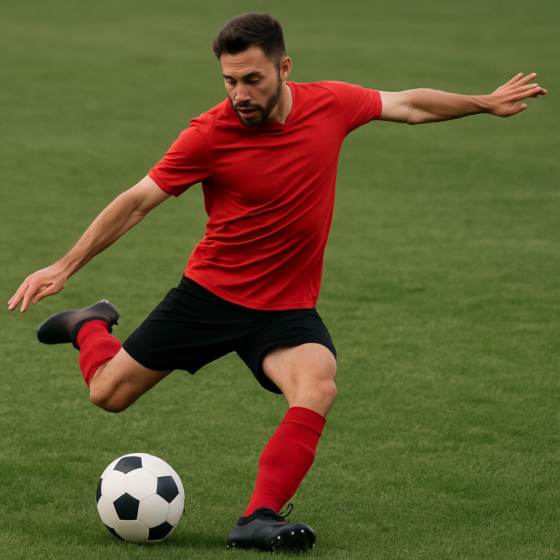

6. Paragraph text #6:

Check out our quick tutorials on dribbling, shooting, and passing. These skills are the foundation for every great soccer player. Master them step by step and take your game to the next level!

Child Page: Game Changer Tips

1. Heading #1 text:

Train Like the Pros

2. Picture #1:

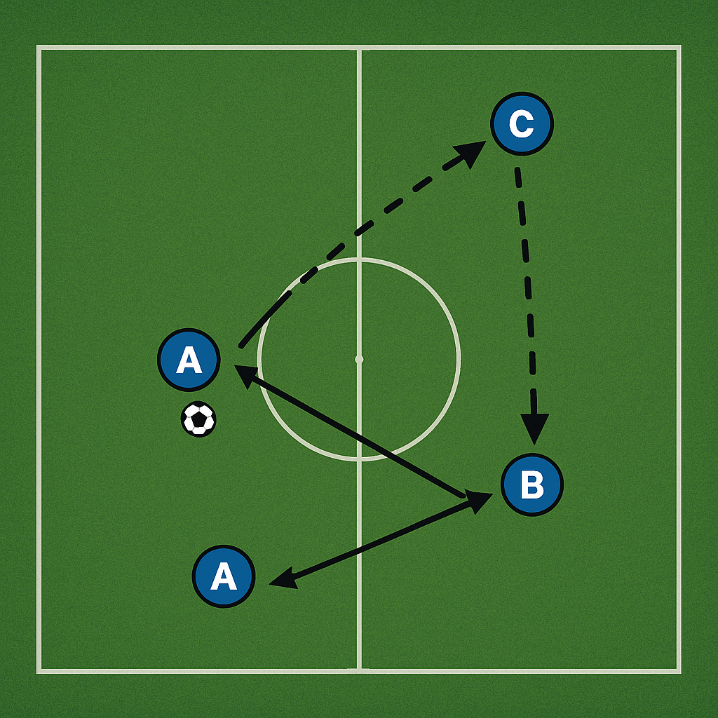

3. Paragraph text #1:

Start with the basics! Learn how to pass, dribble, and shoot with confidence. Each skill comes with simple tips to help you build a solid foundation and play like your favorite pros.

4. Heading #2 text:

Practice Plans & Video Demos

5. Picture #2:

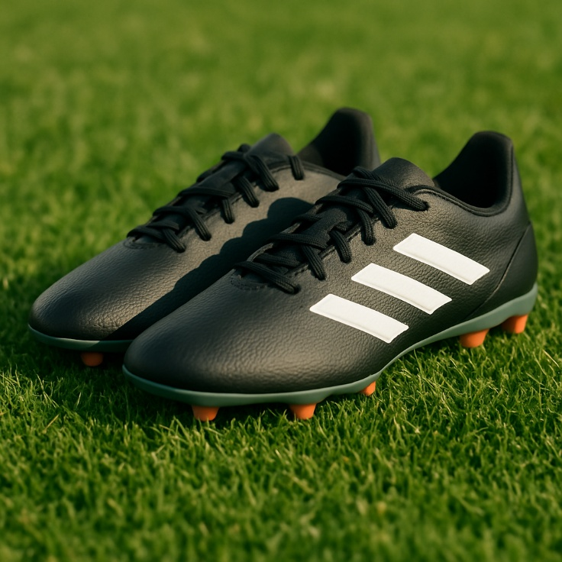

6. Paragraph text #6:

Watch our quick video tutorials and follow along with weekly practice plans you can print out. These drills are designed to help you improve step by step right at home or in the field.

**Child Page #2: Behind the Goals**

1. Heading #1 text:

Real Moments from the Pitch

2. Picture #1:

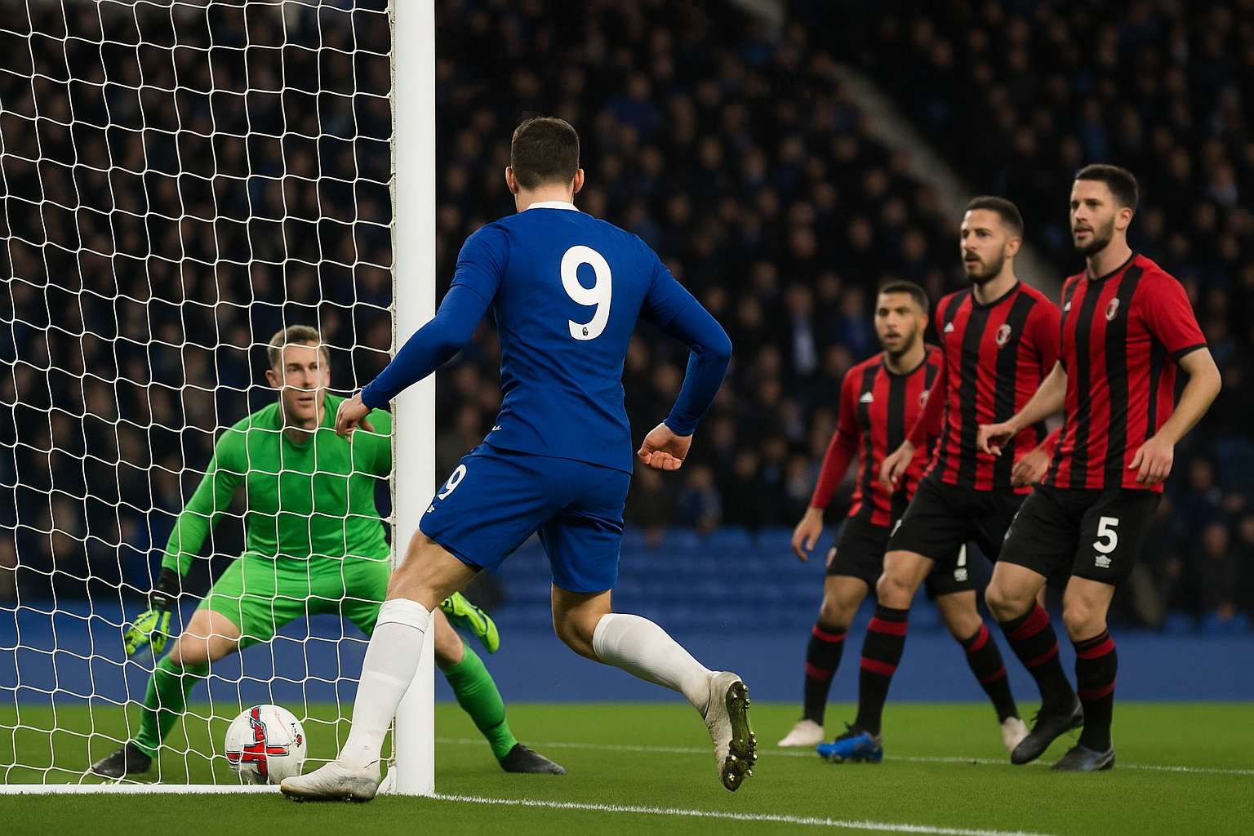

3. Paragraph text #1:

Get inspired by player spotlights and interviews with athletes who share how they train, overcome challenges, and live their love for soccer. These real stories show you what’s possible on and off the field.

4. Heading #2 text:

Fan Stories & Match Highlights

5. Picture #2:



6. Paragraph text #6:

Read fan stories and see match highlights from exciting games around the world. Relive your favorite moments and share your own experiences with our soccer community!

**Wireframes**

### Home

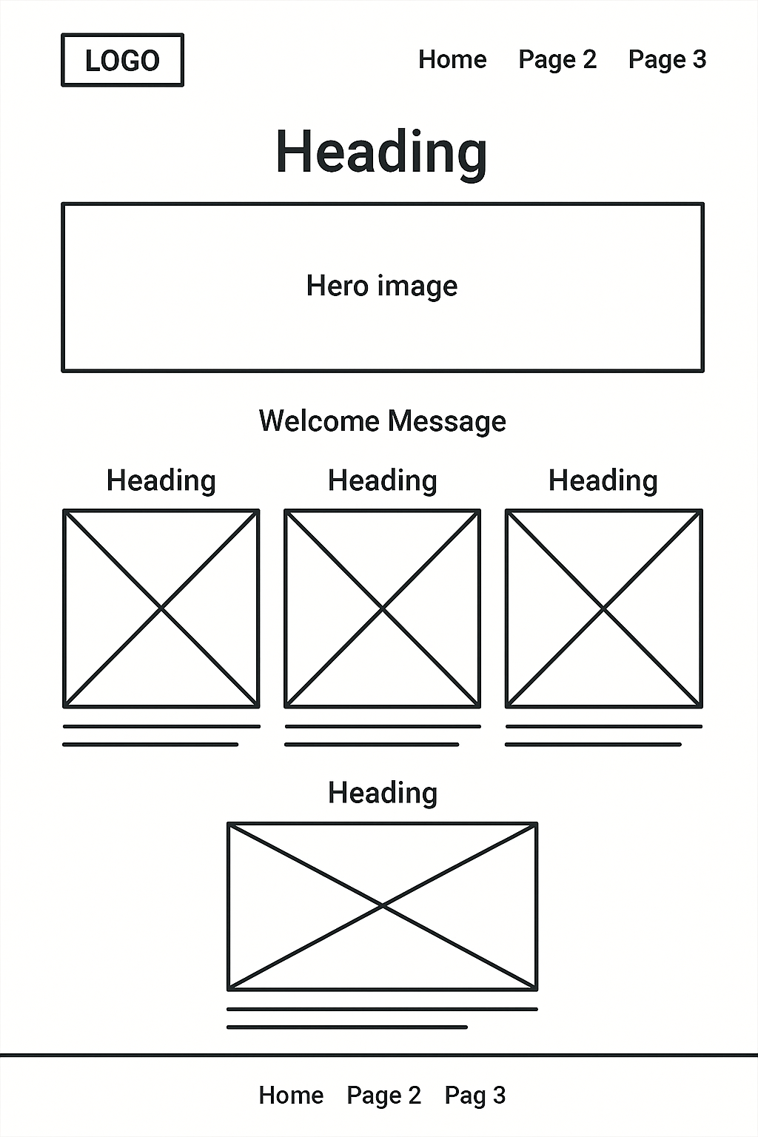

Child Pages #1 & #2: Game Changer Tips & Behind the Goals

